Crisis Management

emergency operation plans (EOPs)
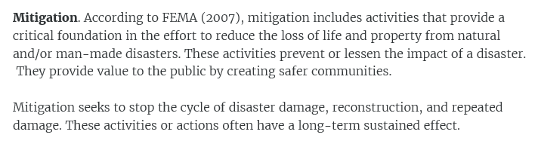
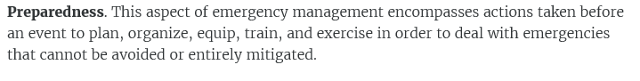
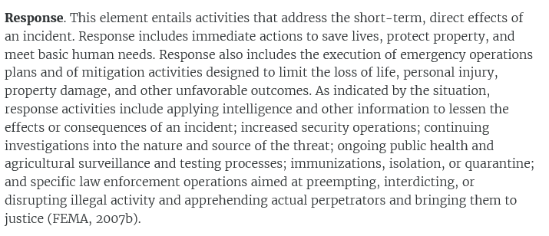
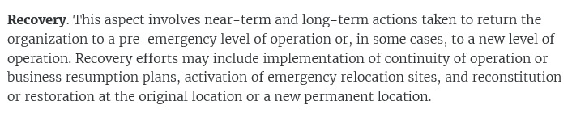

Business continuity (BC) is, in many respects, the private-sector version of emergency management. However, BC adds elements that are not applicable to communities, such as a business impact analysis (BIA).
Continuity of operations, or COOP, is a term applied specifically to the U.S. federal government

Minimize the probability of a threat or emergency
Mitigate the impact if the event occurs
Recover from the emergency and resume normal ops
An effective tool for determining the probability of a threat or a disaster, and its impact on an organization, is to conduct a risk analysis in the development stage of the emergency plan.

Which of the following is not a function of an emergency management plan? DEFINES”EMERGENCY” OM GENERIC TERMS

Types of Threats and Contingencies
The emergencies or contingencies for which emergency plans may be developed can be grouped into three major categories: natural, human (either internal or external), and accidental.

The all-hazards approach has been adopted by FEMA and can be used in business and organizational plans as well as community plans. The approach provides for a basic emergency plan, or emergency operations plan (EOP), with functional annexes (such as emergency call lists) that apply to multiple emergency situations, and threat-specific annexes (such as procedures for bomb incidents). This approach recognizes that many planning requirements are similar regardless of whether an incident is a natural threat, a human threat, or an accident. For example, an evacuation plan is necessary for fires, bomb incidents, and hazmat spills.
- Two significant considerations arise in choosing a planning format.

- A plan is of little value if it is not readily available to those whom it affects. Therefore, the format should facilitate the distribution of the plan to all individuals and organizational elements with designated responsibilities under the plan.
- To be effective, every emergency plan should be reviewed and updated regularly.

A formal audit of the plan should be conducted at least annually. In addition, the plan should be evaluated and modified as required after the following:
- each training drill
- each emergency
- changes in personnel or their responsibilities
- changes in the facility’s physical design
- changes in policies or procedures

The most important thing about planning: it is a continuing process that is never finished as long as the plan exists (ASIS, 2005, 2009; FEMA, 1993; NFPA, 2010).
When should emergency response agencies outside the organization be contacted during an exercise? WHEN THE AGENCY IS INVOLVED IN THE EXERCISE
One of the most important considerations in developing an emergency management structure is to designate alternates for the primary decision maker and for anyone else who is charged, by name or position, with a particular responsibility under the plan.
A totally new organization should not be developed to handle emergencies. Such problems should be handled by the existing organization, temporarily reconfigured, along with executives responsible for the day-to-day operation of the enterprise (ASIS, 2005, 2009; Broder, 2006; FEMA, 1993; NFPA, 2010).

Incident Command/Management
The Incident Command System (ICS) is a command and control mechanism used by many public safety agencies and jurisdictions in the United States. ICS provides an expandable structure that can be used as needed to manage emergency agencies. Although some of the details vary by jurisdiction, ICS normally consists of five primary elements:
- command
- operations
- planning
- logistics
- finance and administration
crisis management team (CMT).
emergency operations center (EOC)
Distribution of the published plan with the telephone list should be limited to control centers and senior personnel with plan implementation responsibilities. This will ensure as much privacy as possible for individuals who have unlisted numbers or desire a limited release.
How should a list of emergency phone numbers for key personnel be distributed? CONTROL CENTERS AND SENIOR PERSONEL WITH PLAN IMPLEMENTATION RESPONSIBIITIES
What is the term used to describe when businesses and other organizations agree to assist each other by providing materials, equipment, and personnel for disaster control during emergencies?
MUTUAL AID ASSOCIATIONS

When should names of people killed or injured in a crisis be released to the media?
ONCE RELATIVES OF CASUALITIES ARE NOTIFIED
When should an organization use its own vehicles to transport the injured in an emergency?
WHEN AVAILABLE AMBULANCES CAN’T HANDLE ALL THE VICTIMS OR REACH
THE FACILITY

How should security staff be deployed during a disaster? 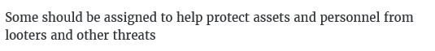
Who should be assigned the responsibility for equipment shutdown in an emergency?
THOSE MOST FAMILIAR WITH THE PROCESS
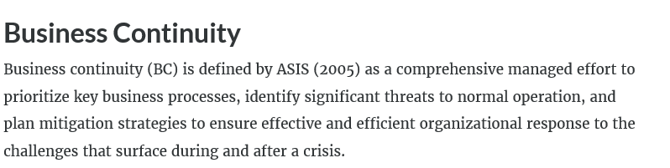
A business impact analysis (BIA) is an integral part of the business continuity planning process. It is used to identify an entity’s critical functions, to assess the impact of a disaster or other emergency on those functions over time, to determine the other elements of the business on which those critical functions depend, and to help develop and prioritize recovery strategies.

Vital Records
Arrangements for storing vital backup records should be integrated into BC and COOP planning. Vital records are those that are necessary to ensure the survival of a business.

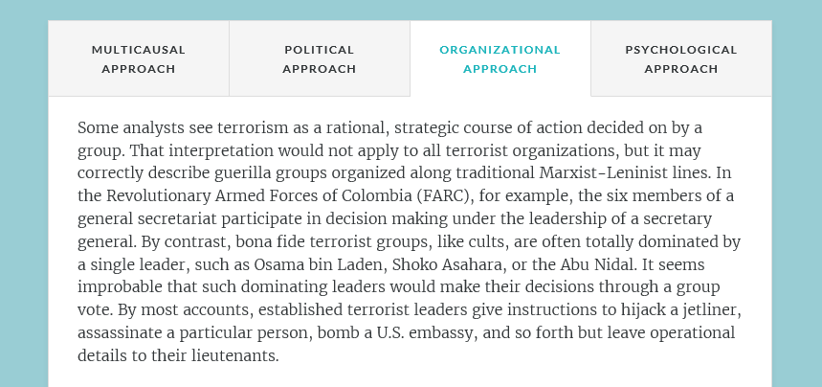
Where does today's most dangerous extremist threat come from? GLOBAL JIHADIST MOVEMENT
In general, how effective has CBRN terrorism been as a tactic? MARGINALLY
What is the most dramatic recent development in individual weaponry? PRESICION GUIDED
WEAPONRY
What is the most common type of terrorist activity? Conventional bombings
Which of these is not an essential element of a bombing? MALICE
What is the one element of a bombing that an organization can control through its bomb security management plan? OPPORTUNITY
Which is the most likely type of bomb incident? UNATTENDED ITEM
What are the 5 R's of bomb threat evaluation?receive, record, report, review, respond
In a bomb threat assessment, the question is whether the threatener could have done what is claimed (e.g., placed a bomb on-site). A coordinated, trained, and practiced threat evaluation team (TET)
Where possible, the evacuation assembly areas should be at least 300 meters (328 yards) from the building, not in a direct line of sight of the bomb, not facing or under windows, and behind solid cover, such as another building.

What would typically be the proper course of action when finding an unattended school backpack, whose contents can't be seen, in the foyer of an office? ASSUMING NO X-RAY IS AVAILABLE AND IT DOESN’T SEEM LIKE A THREAT, OPEN IT GENTLY
Which is not a product of an explosion? CARBONDIOXIDE

