Business Practices

Admin Mgmt Principles

Enterprise Security Risk Management (ESRM)
Enterprise Security Risk Management (ESRM) is a strategic security program management approach that ties an organization’s security practice to its mission and business goals using globally established and accepted risk management principles.
ESRM recognizes that security responsibilities are shared by both security and business leadership, but that all final security decision making is the responsibility of the business leaders. The role of the security leader in ESRM is to manage security vulnerabilities to enterprise assets in a risk decision-making partnership with the organization leaders in charge of those assets.
What is the term for a strategic security program management approach that ties an organization’s security practice to its mission and business goals using globally established and
Enterprise Security Risk Management (ESRM)

Which is an indirect job requirement? Comm skills Not certs, ed level or previous job responsibilities
What is the best way to recruit a new candidate? Internal recommendations
Against which document should staffing decisions be measured? Job requirement analsysis

Besides the security department, who should routinely have a hand in developing security policies?
Managers whose teams will be most affected.

Which metric assesses an employee’s contribution to the company as a whole, as opposed to how well they are performing their job? Leadership (not in reading materail!)

What is an organization’s SECOND most valuable resource? Corporate Knowledge 1st is people

What is the first step in creating a corporate structure? Identify essential business units

FINANCIAL MANAGEMENT

By law, who must follow accounting and financial reporting standards? Both Private and public companies

What is the first step in establishing a financial strategy? Identifying expected margins
What is the best way to fund business growth? It depends on the results of analysis of financial statements
What is the main shortcoming of the income statement? It doesn’t indicate overall financial health
What is another term for operating costs? Administrative costs
How is shareholder equity derived? Retained earnings, net income and dividend payout
A company has collected a payment for services rendered without having yet rendered those services. This would appear on a balance sheet as what? Liability
Which financial statement provides insight into the asset and liability mix and how it relates to shareholder equity? Balance Sheet
How are raw materials listed on a balance sheet? Inventory
Which is NOT indicated on a cash flow statement? Payroll cash flow
How do you calculate operating margin? EBITA/Revenue
How do you calculate return on equity (ROE)? Net Income/Shareholder Equity
Current Ratio = Current Assets/Current Liabilities
Debt to Equity Ratio = Total Liabilities/Shareholder Equity
Quick Ratio = (Cash + Securities + Accounts Receivable)/Current Liabilities
A company can cover all of its current liabilities with current assets when its current ratio ________.
Is greater than 1
What is the biggest limitation in the analysis of financial statements? It doesn’t directly consider changes in marketing conditions
What is a key advantage of zero-based budgeting? It may force managers to consider alternative ways to get the job done
Which is a viable method for calculating ROI for research and development (R&D) activities? Via R&D’s average historical return.
A budget should resemble which financial statement? Income statement
BUSINESS ETHICS
Which branch of ethics is most relevant to business? Applied Ethics
There are no true ethical values that prescribe behavior.” This philosophy is an example of what kind of reasoning that leads to unethical choices? Relativism
Most evidence supports the proposition that ____. Being ethical leads to greater long term success
Which statement is true regarding corporate codes of conduct? They should apply to all
Corporate ethics codes should always be _____. Field tested before widely disseminated
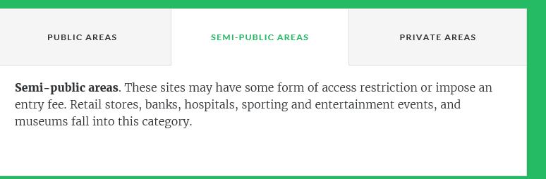
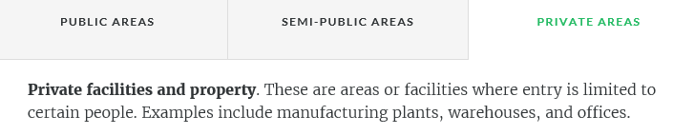
What is typically the largest item in the operating budget of a security department?
What document, prepared and distributed prior to a Request for Proposal, is designed to give vendors as much information as possible, such as procurement rules and payment policies, so they can produce comprehensive proposal packages? Solicitation Summary

